#### 

#### IFT 598 Middle Programming and Database Security

#### Shraddha Surendra Kumbharkar

# Module 2 Assignment: JavaScript language

#### Professor, Dinesh Sthapit

September 10 by 11:59pm

#### 

#### 

#### 

#### **Introduction to JavaScript**

#### Created a new project and run npm init

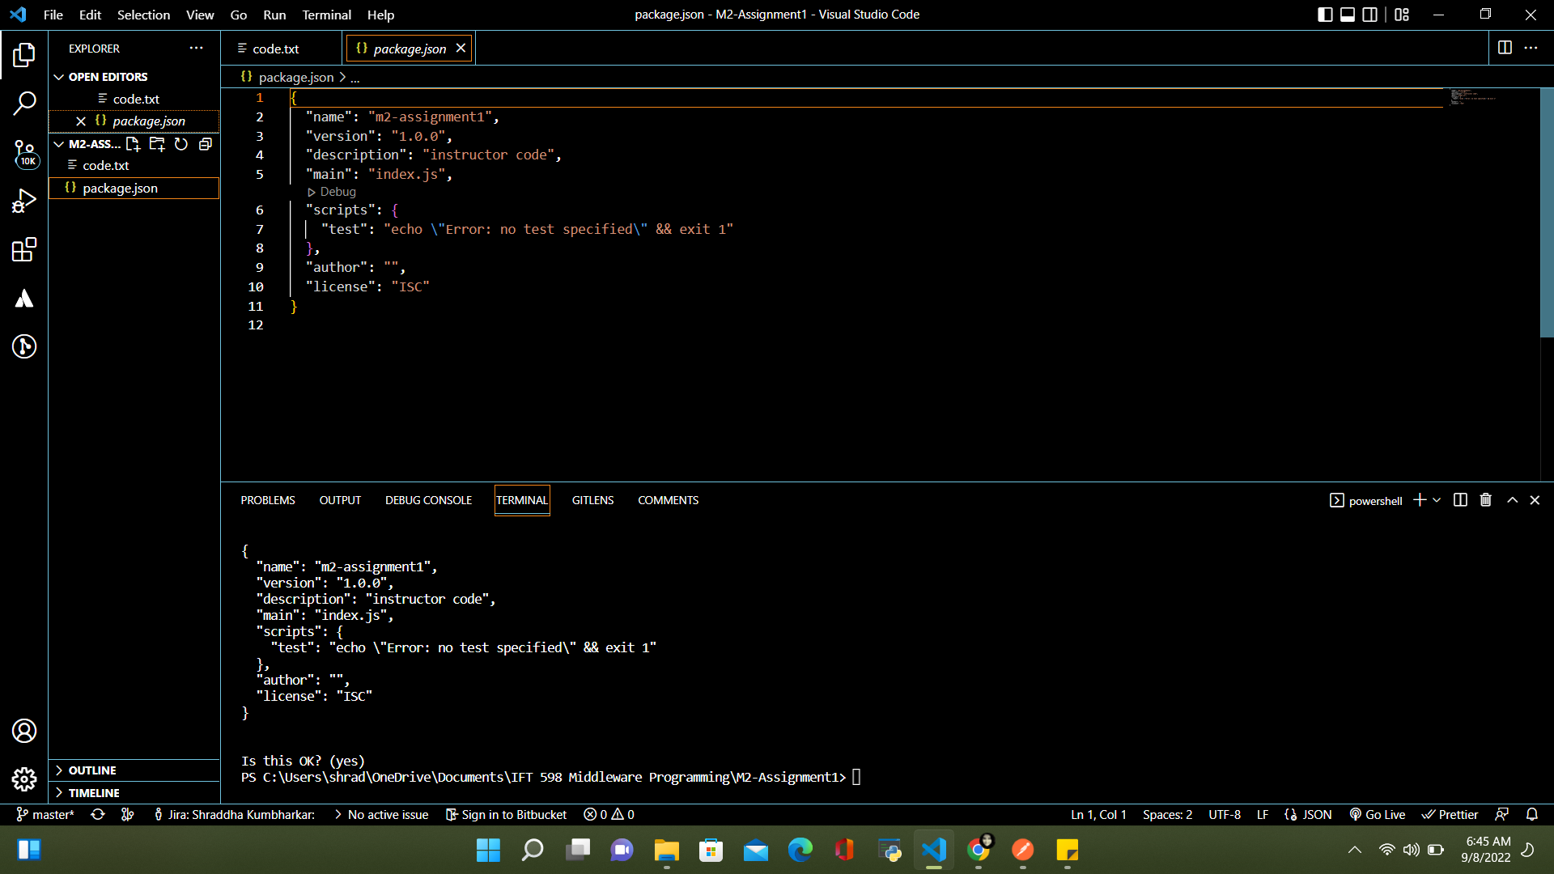

Created index.js and wrote first code in JavaScript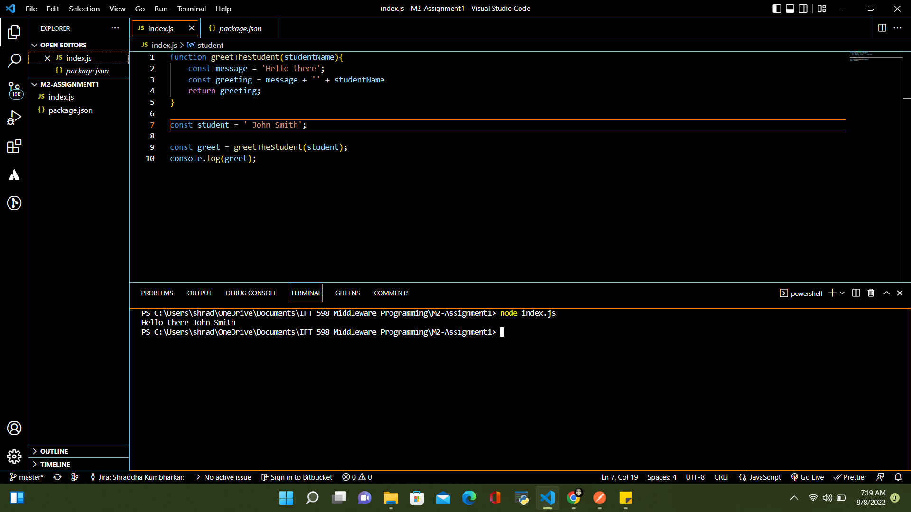

Running simple code only by returning value i.e student name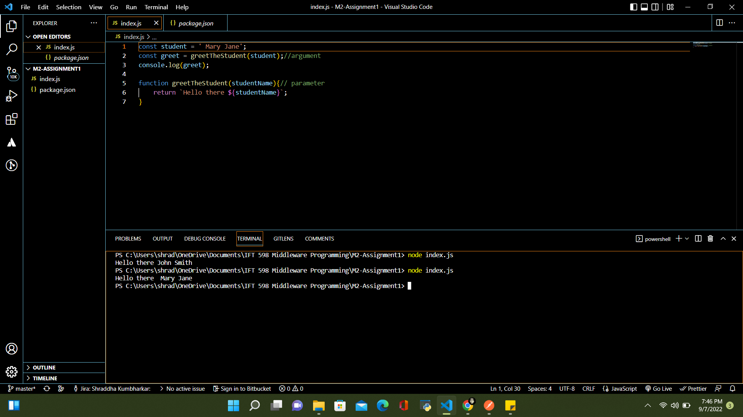

**JavaScript Function Refactoring**

Code with an anonymous function 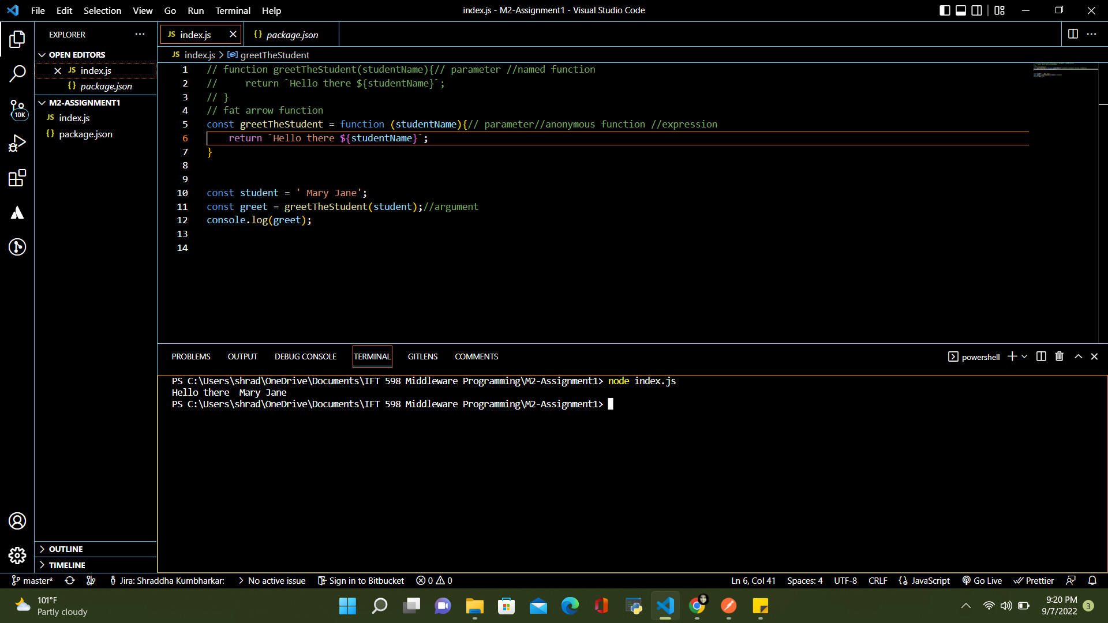 Code using fat arrow function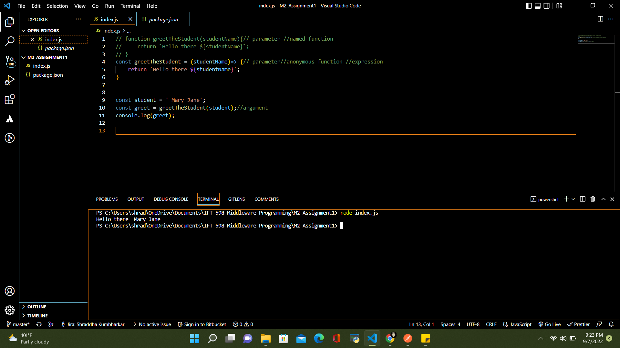

Optimizing the code if there is only one parameter to pass

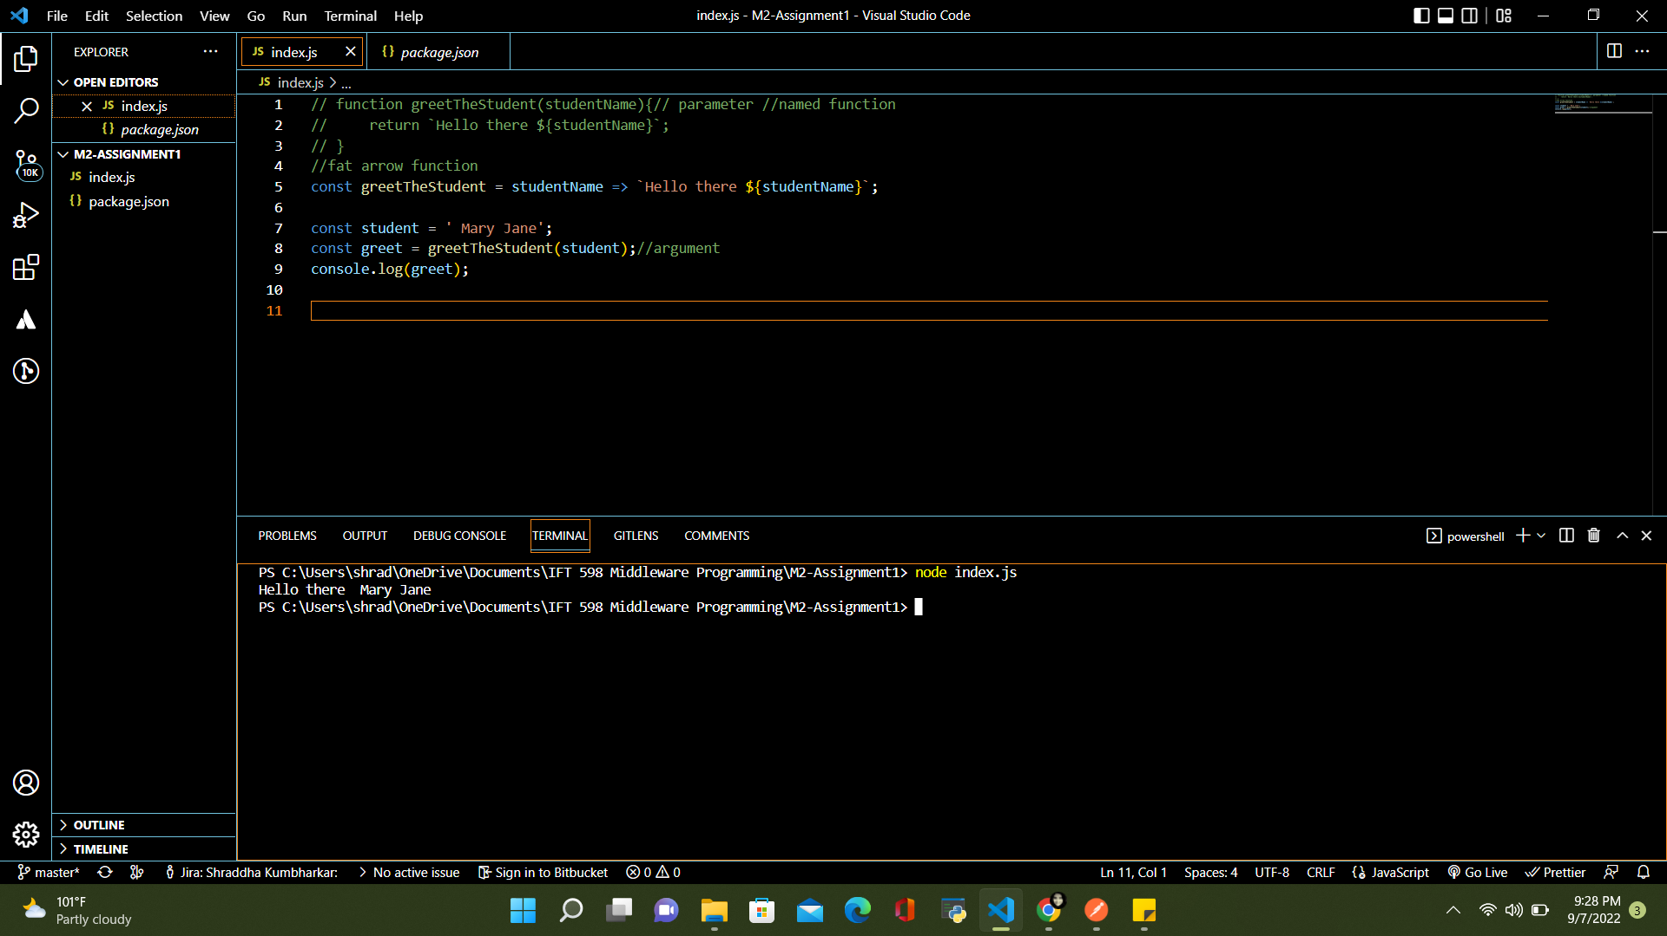

**JavaScript Refactoring**

Another example of displaying name with multiple parameters

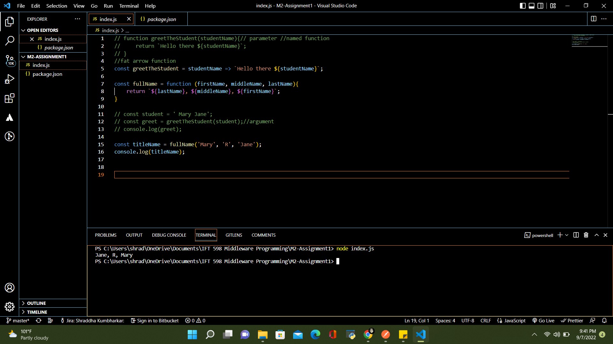

Example with anonymous function

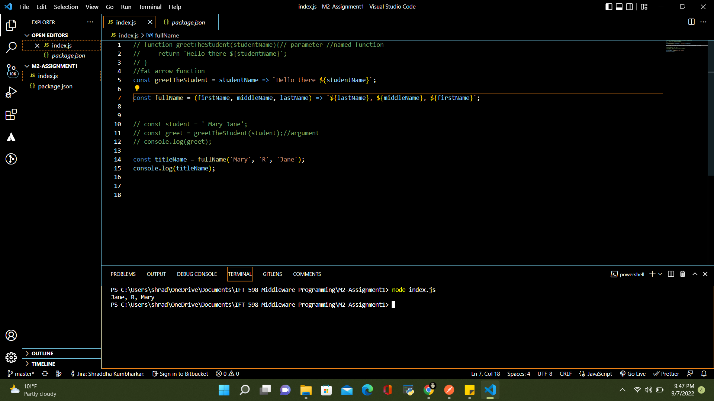

**JavaScript Variables**

Displaying the type of variable using the typeof operator on console

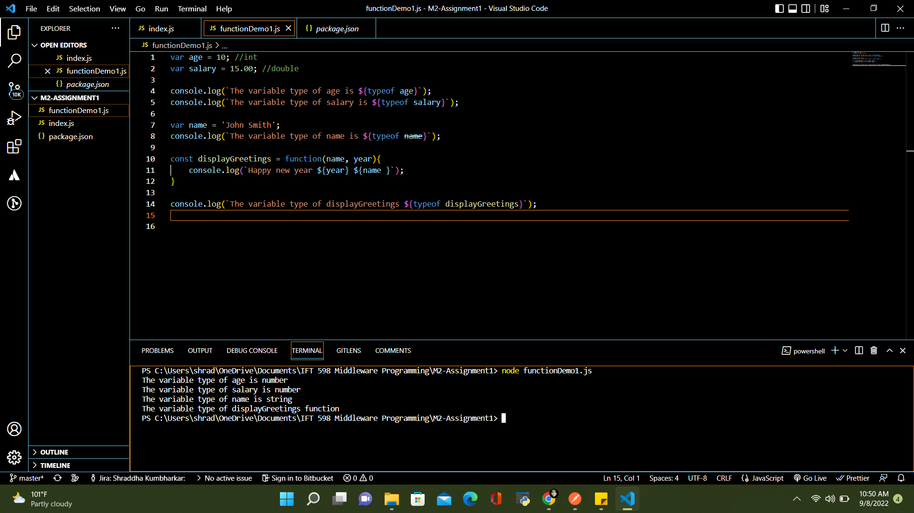

Display function using condition

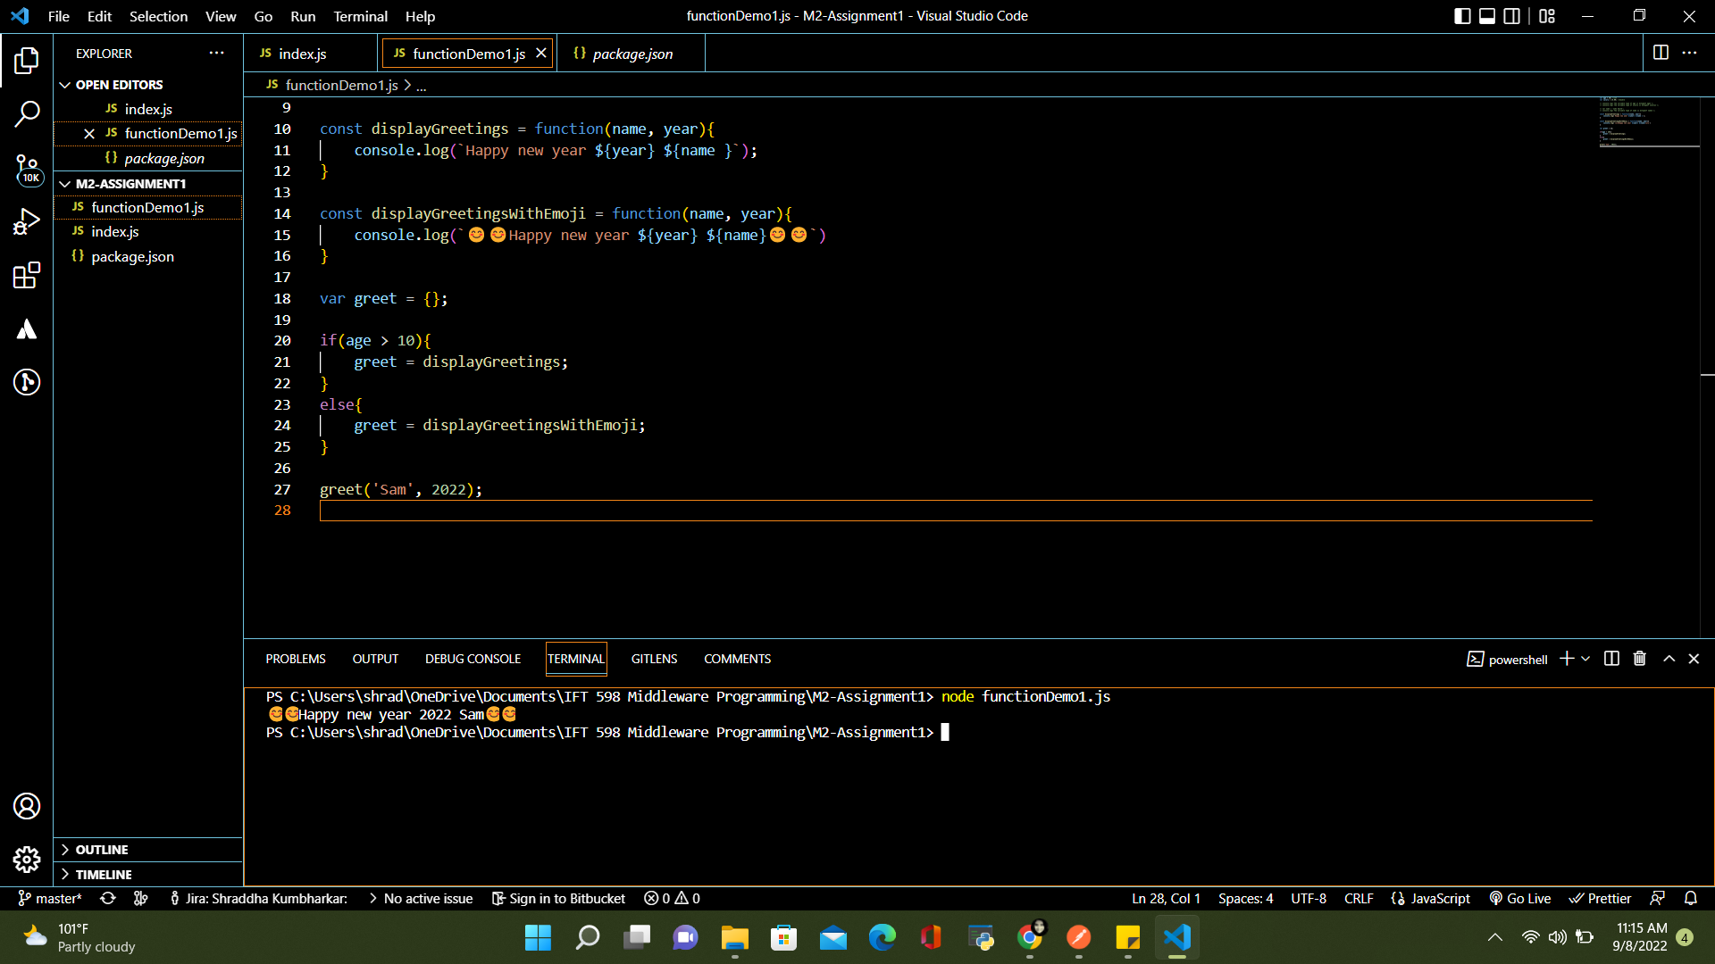

**JavaScript Parameter (Function as a parameter)**



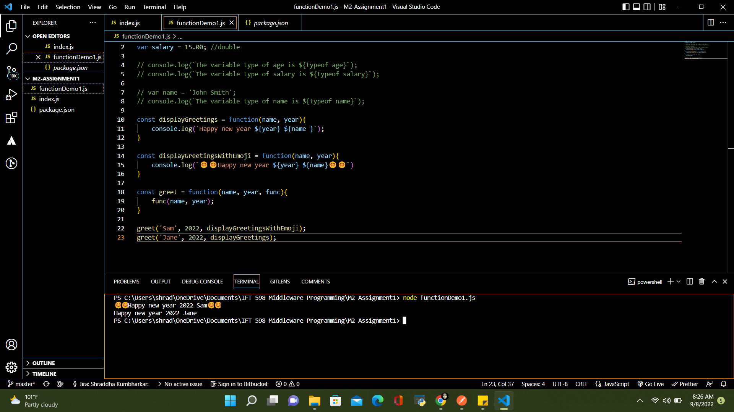

**JavaScript Objects**

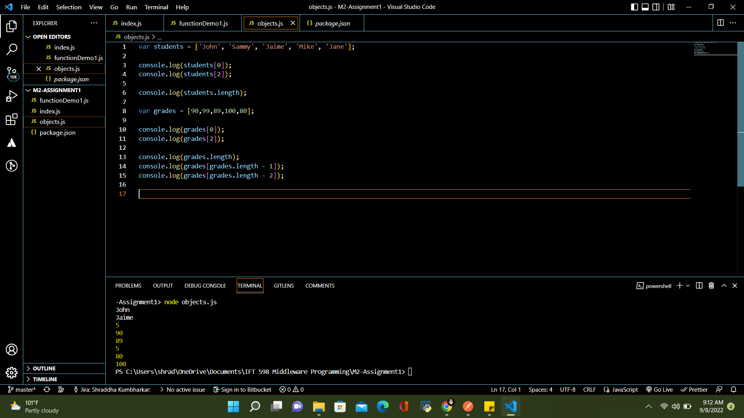

**JavaScripts Arrays**

Passed array elements by declaring objects and add function to an element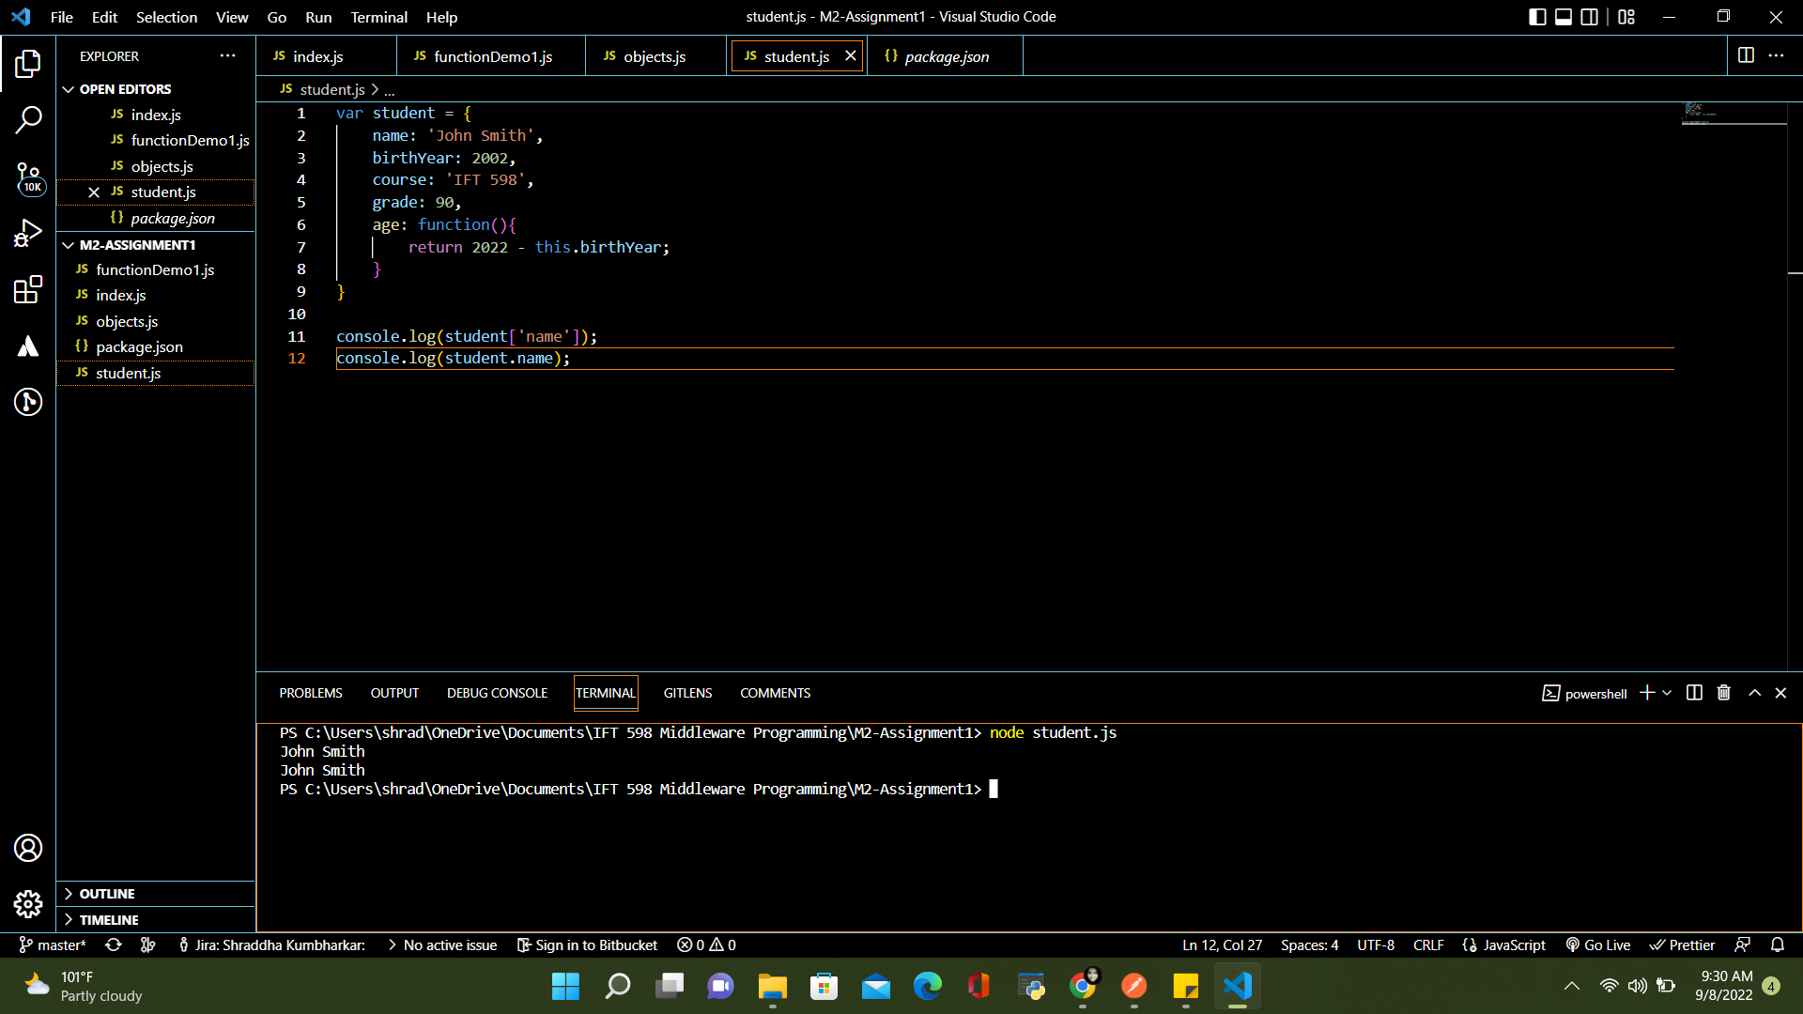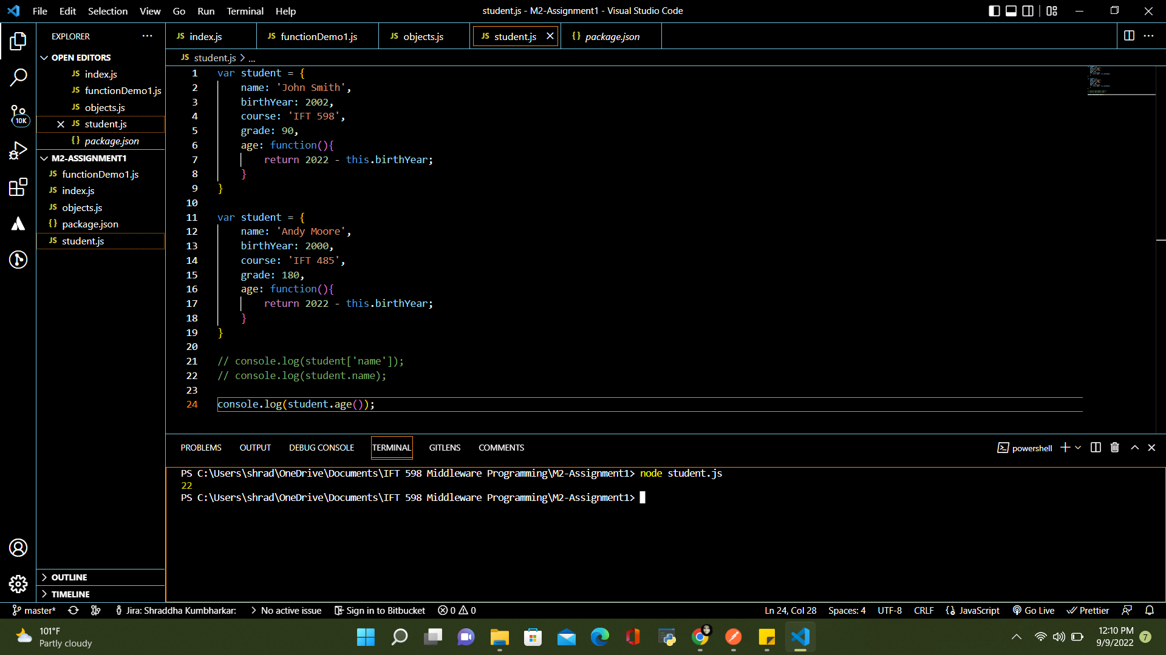

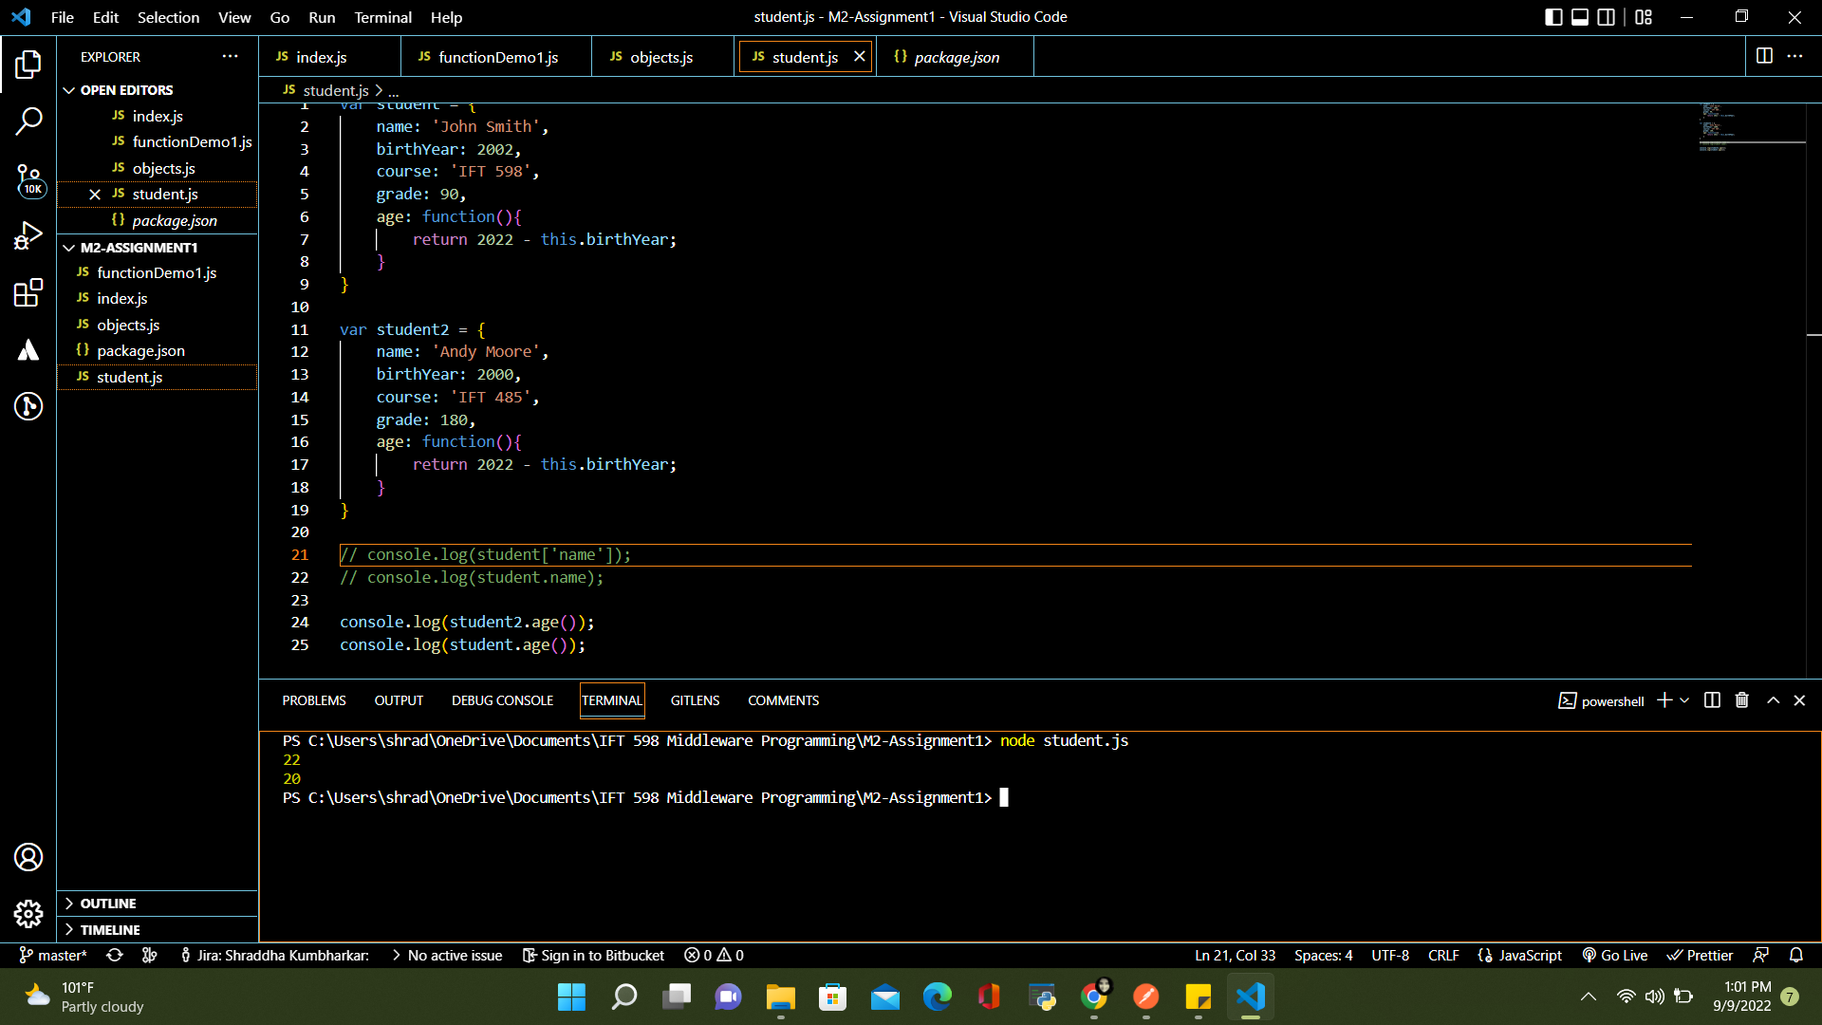

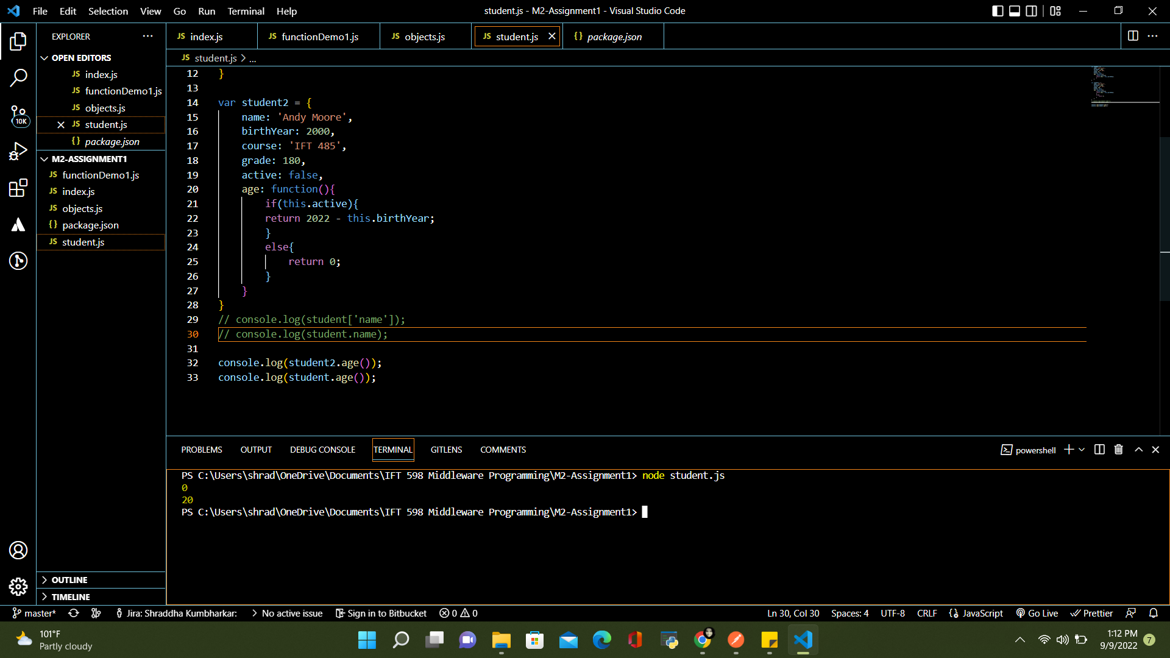

Accessing Elements of JavaScript Object Arrays

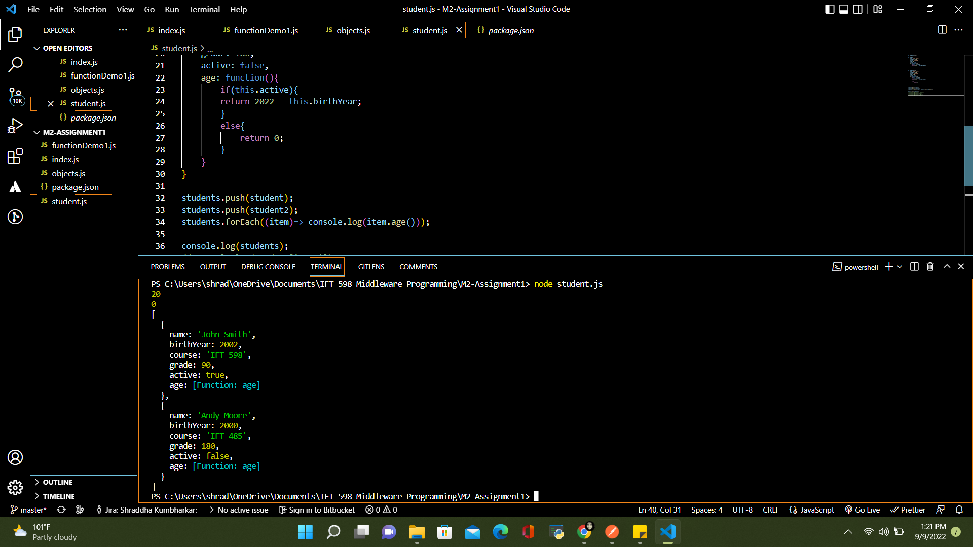

**References**

<https://asu.instructure.com/courses/132658/assignments/3526657?module_item_id=9146086>

# Module 2 Assignment: JavaScript language